The Metal Age.
a) Innovations in the Metal Age. About 4.000 years ago, human beings began to use some objects of metal. The first metal they used was cooper, but it was not very resistant and they used it only to make ornaments and small weapons. Later they used bronze (an alloy of copper and tin), and finally iron, not used until the end of Prehistory, with which they could make all kinds of instruments: tools (hoes, axes and sickles), weapons (swords, daggers, lances and shields), jewels, statues, and domestic tools (cups, jugs and bowls).
In the same period, in the Middle East, they made three important inventions: the perfected wheel, the sail and the plough.

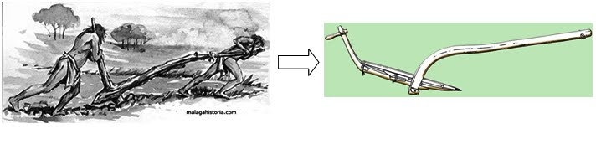

- the first one was a perfected wheel to make pottery and carts.
- it was the first time that ships used salis to take advantage of the force of the wind.
- the plough permitted the tilling of a greater area of land faster than the hoe.
The search for raw materials to make new tools gave rise to the beginning of trade activities.

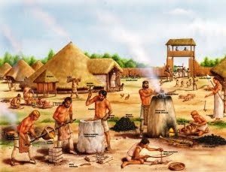
b) The first cities. The development of agriculture and cattle raising, together with new techniques, improved living conditions. Because of this, population grew. Some villages got to have hundreds of inhabitants, and became small cities.
Cities, surrounded by walls, had buildings with different functions: houses, stores, shops or workshops. Houses were small, with walls made of adobe or stone and ceilings made of straw.

c) The new society. In the Metal Age the complexity of society grew. New needs produced a new social division into an elite and craftsmen with special knowledge. This could be because of the increase of agrarian production by the use of new instruments.
We can study this social division through individual graves in which we found their properties.

d) Megalithic monuments. In the last years of the Neolithic Age human beings began to build monuments with big rocks of stone, called megaliths. The main megalithic monuments were menhirs, dolmens and cromlechs.
- Menhirs were big, long stones vertically trust into the ground. Their construction is probably related to the cult of the sun.
- Dolmens had big, long vertical stones which formed a wall and had a cover of several horzontal stones, also of a great size. We don't really know their meaning but we think that people used it as cemeteries.
- Cromlechs were wide circles formed by several menhirs. Its use was as sanctuaries. One of the most known is Stonehenge in the United Kingdom.
- There is another kind of monuments called tholoi used like collective graves.

ACTIVITIES

26. Which could be the differences between the use of a plough and a hoe?
27. List the main inventions made in the Metal Age and explain them.
28. Explain these concepts: a) megalithic monument, b) Metal Age, c) dolmen.
29. Analyse why trade was strongly developed during the Metal Age.

Sources:
http://bertan.gipuzkoakultura.net/es/20/en/9.php

STONEHENGE -Wiltshire, England

YouTube Video
https://www.youtube.com/watch?feature=player_embedded&v=5yz0xNkMmAI

